**IAM,VPC,EC2**

STEP 1 & 2:-

CREATE A AWS FREE TIER ACCOUNT AS A ROOT USER SO THAT WE CAN WORK IN GROUPS AND ALSO TO CREATE SUB ACCOUNTS FOR WORK MANAGEMENT

ROOT USER

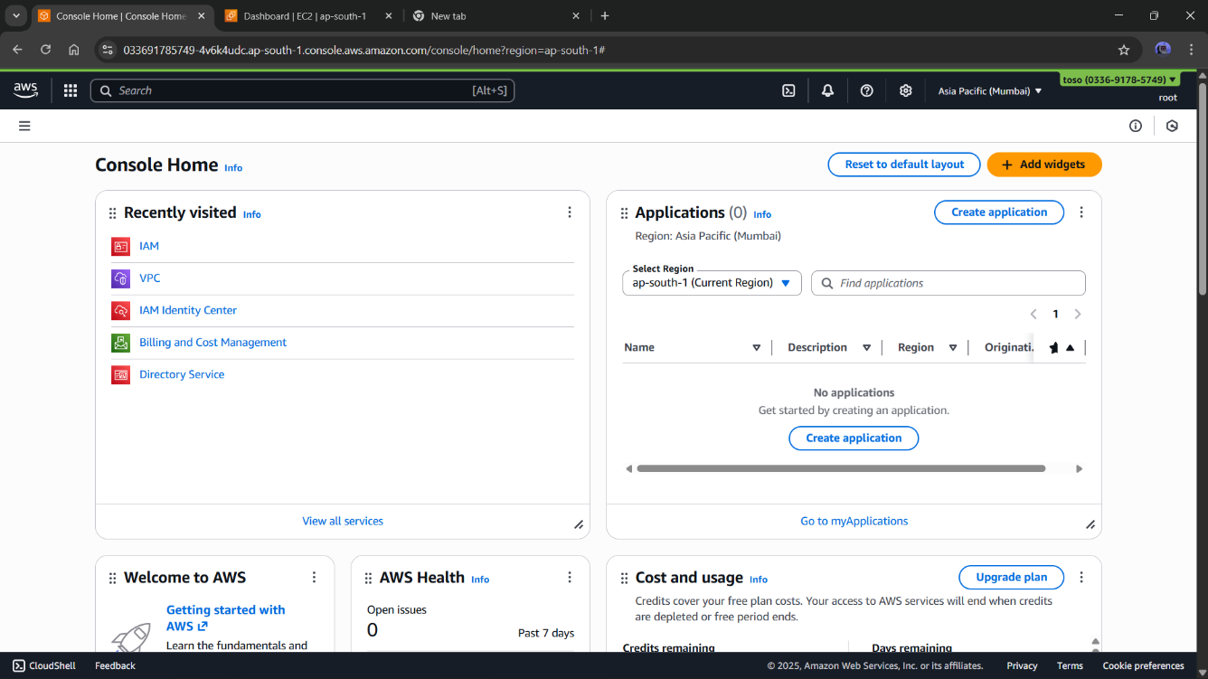

IAM

NOW WE GO TO IAM AND CREATE A USER THERE TO WORK WITH WE DON’T USE OUR ROOT ACCOUNT FOR WORKING WE CREATE USERS THERE FOR WORK WE USE DIFFERENT USERS FOR DIFFERENT WORK THIS WILL HELP US TO MANAGE THE BILLING AND POLICIES EASILY   
ROOT IS UESD TO MANAGE THOSE IAM ACCOUNT IT’S LIKE A BOSS IS RUNNING THE COMPANY HE WILL PAY AND GET THE WORK DONE BUT HE WILL NOT WORK

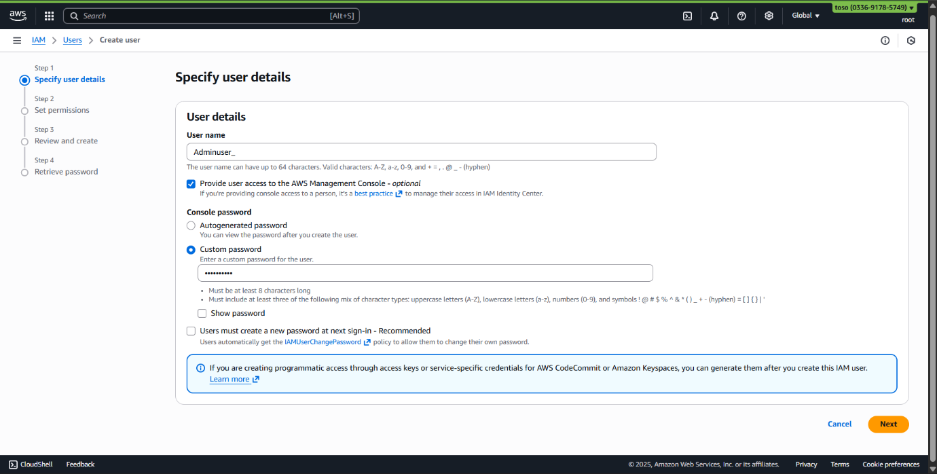

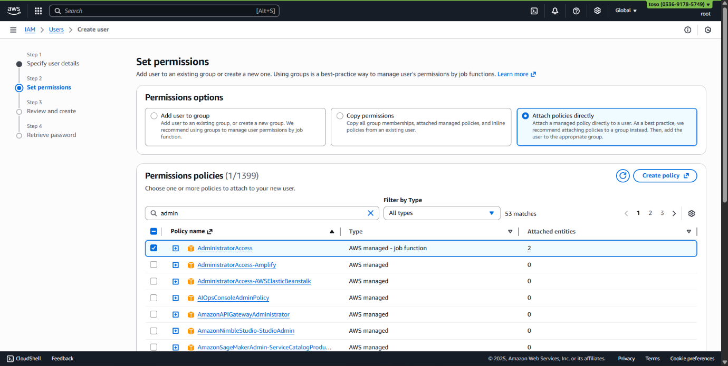

* HERE WE CREATE AN ADMINUSER IAM USER IN OUR ROOT ACCOUNT WE GIVE IT PERMISSIONS OF ADMINISTRATORACCESS AND ALSO WE ADD A MFA IN IT AND ALSO A ACCESS KEY FOR SAFETY AND NOW OUR STEP 1ST AND 2ND ARE COMPLETED NOW LET’S MOVE TO STEP 3RD FOR STEP 3RD WE WILL USE THE ADMINUSER ACCOUNT WE JUST CREATED BY OUR ROOT ACCOUNT

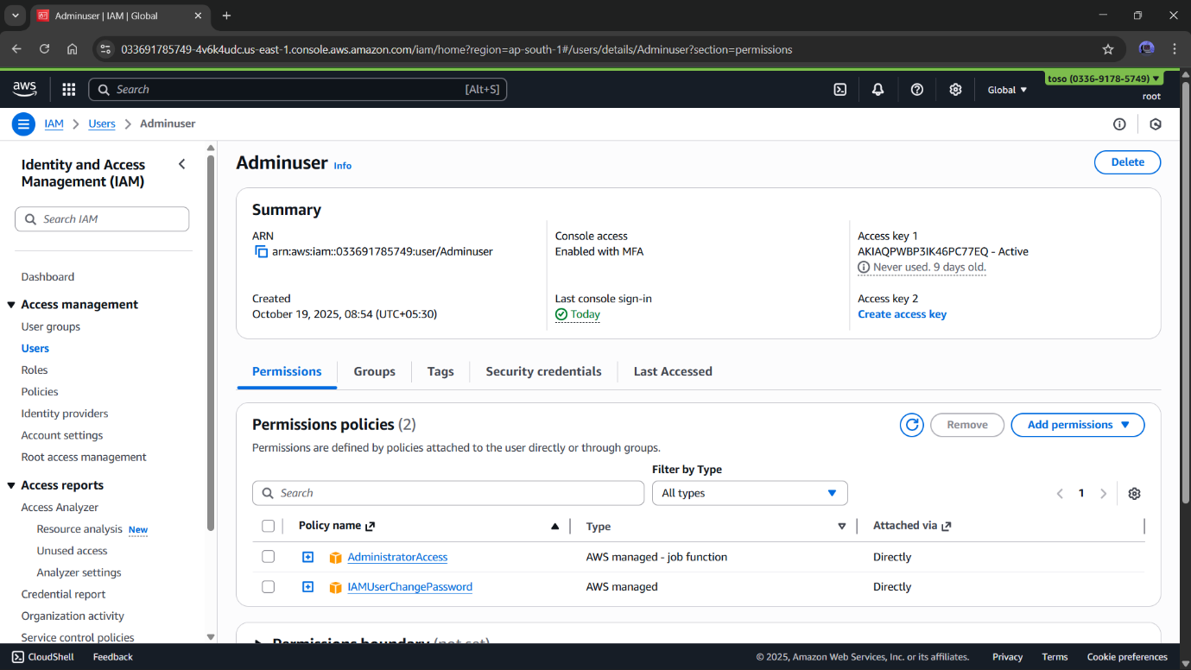

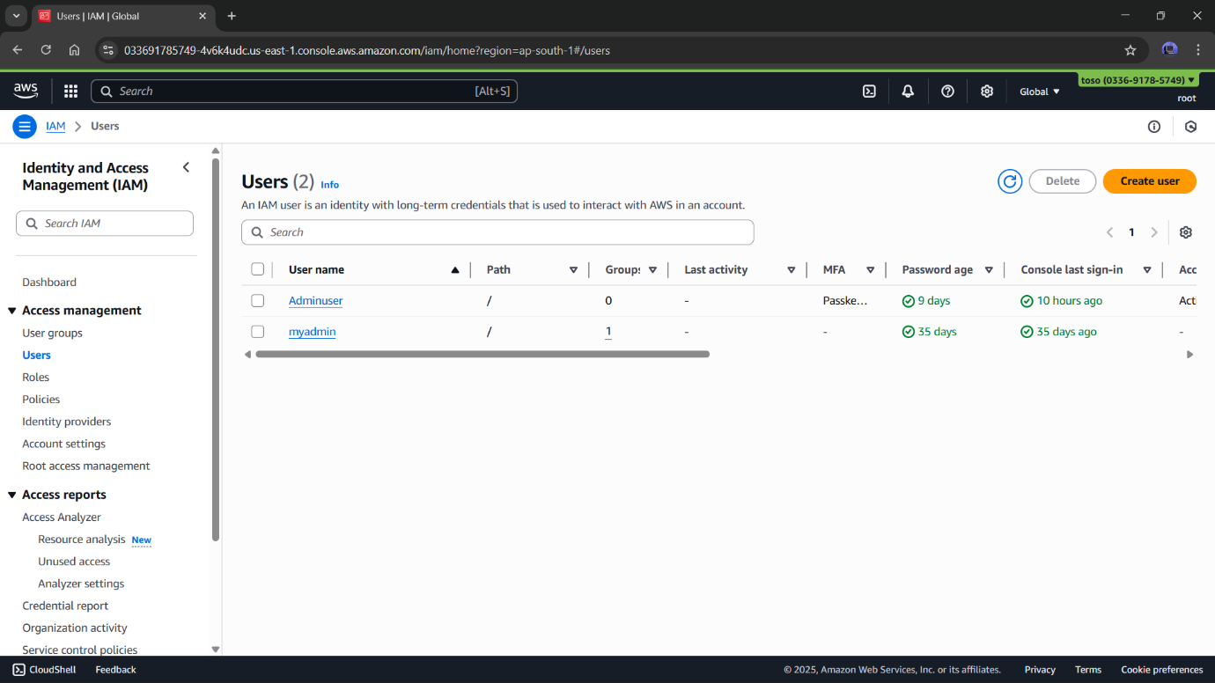

STEP 3

HERE WE ARE IN OUR ADMINUSER ACCOUNT NOW WE GO TO THE VPC SECTION AND HERE WE SAW THAT THERE IS ALREADY A VPC AVAILABLE IN OUR ACCOUNT IT’S A DEFAULT VPC BY AWS IF YOU WANT TO CREATE YOUR OWN SO YOU CAN BUT FOR WE ARE GOING WITH THIS

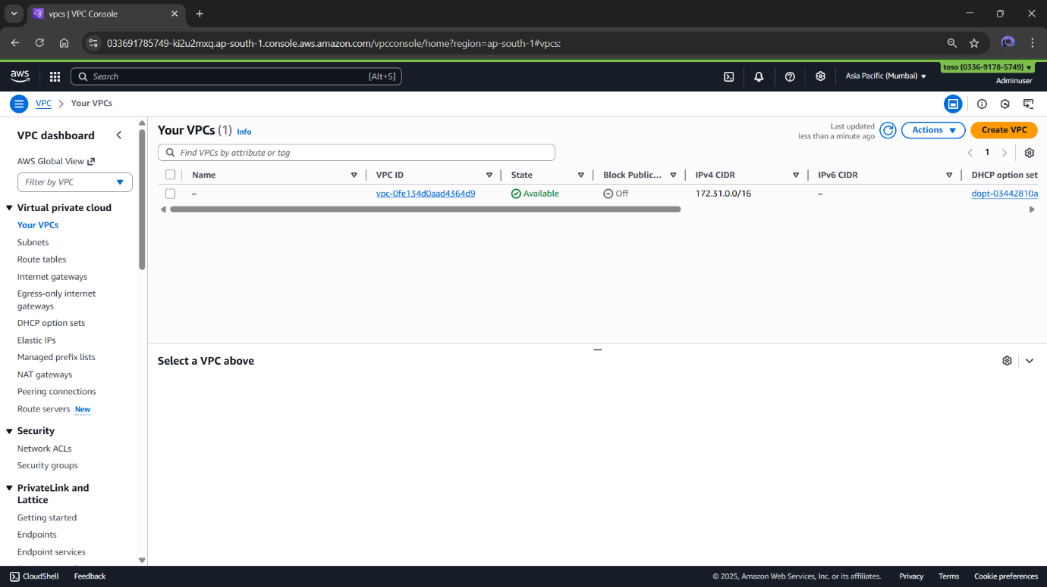

* IF YOU DELETED THE VPC AND WANT TO CREATE YOU OWN SO YOU CAN DO THAT AND IF YOU AREN’T ABLE TO CREATE VPC SO YOU CAN CREATE A DEFAULT VPC AGAIN YOU CAN SEE IT HERE

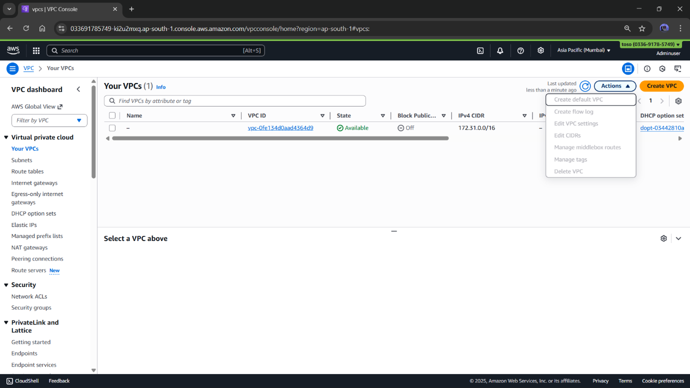

DEFAULT VPC

STEP 4 ,5 & 6

IN THIS WE WILL CREATE A EC2 INSTANCE TO RUN OUR WEBSITE AND ALSO WE PERFORM RDP WITH ACCESS KEY PAIR AND BY FLEET MANAGER

LAUNCH INSTANCE

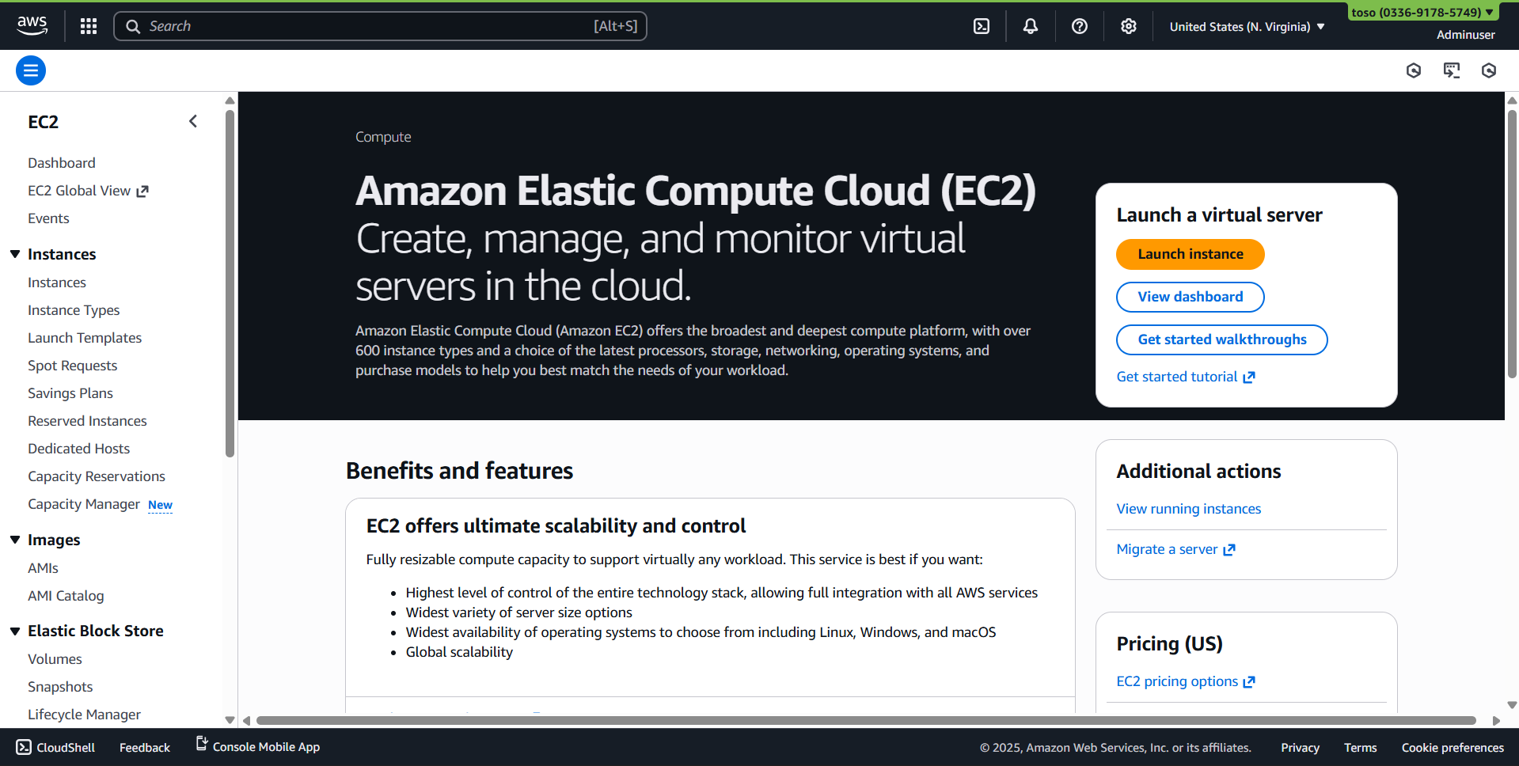

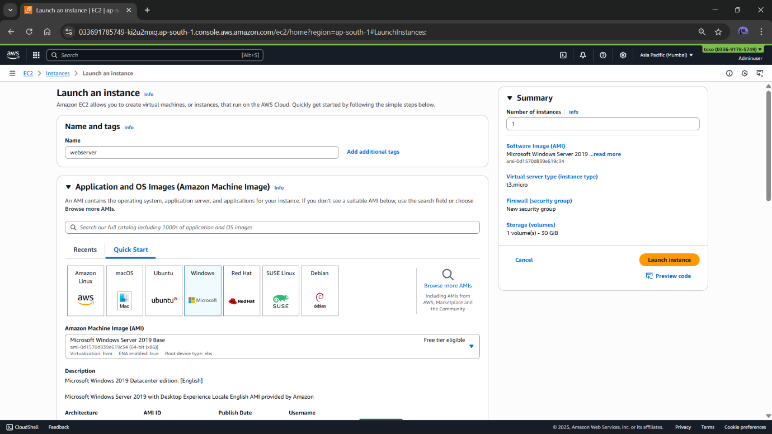

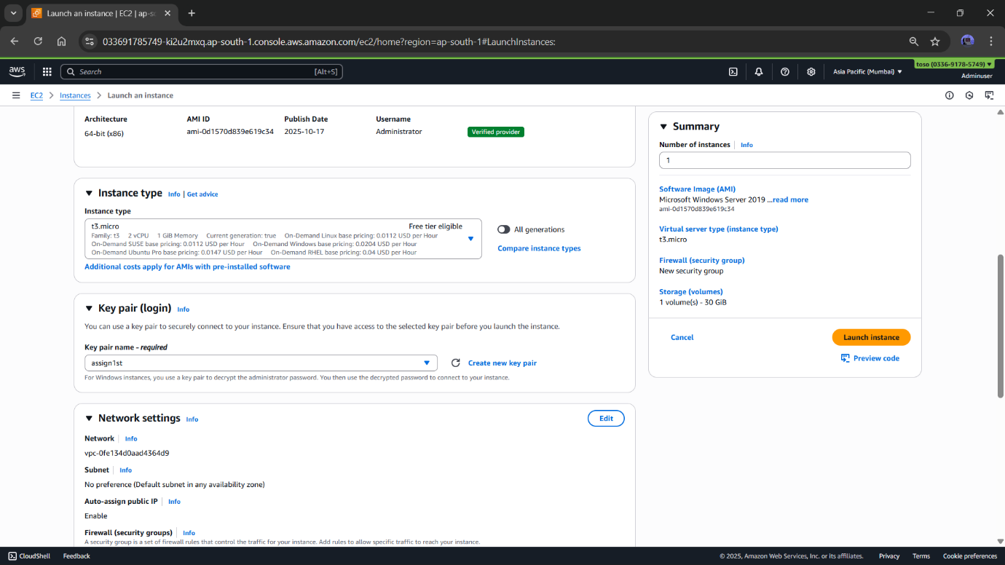

CREATE NEW KEY PAIR

